Yogis Scriptorium
Class 5 - Homework
Mulamadhyamakakarika
– Arya Nagarjuna (2nd Century)

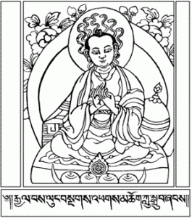

- Define Svabhava and list the indo European roots and some English cognates.

- Define Intrinsic.

- Give the Tibetan and Sanskrit for ultimate and conventional reality and talk about some of the etymological meanings.

- The Samdhinirmochana Sutra talks about how ultimate and conventional reality are neither one nor different. Give some of the analogies they give to talk about this idea.

- What is a third truth that is talked about in the Chinese traditions.

- Describe what is meant by an exegetical way of understanding the two truths?

- Describe what is meant by a non-exegetical way of understanding the two truths?

- What are the positive and negative effects on our mind of too much emphasis on ultimate reality and too much emphasis on conventional reality.

- If I say that conventional reality is valid doesn’t this give validity to the way I perceive things? Explain?

- Is emptiness intrinsically real since it is what is discovered by the undeceived mind? Explain.

- In what way did Je Tsongkapa’s understanding of the two truths impact the success of the Gelugpa order.

- List three reasons why the study of the two truths is important.
a.

b.

c.

